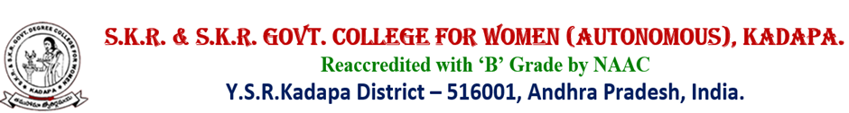
DEPARTMENT OF COMMERCE
STUDENT PROGRESSION - EMPLYMENT

Sl.No. | YEAR | NAME OF THE STUDENT | PROGRAMME  GRADUATED  FROM | NAME OF THE EMPLOYER
1 | 2021-22 | M.SREE DEEPA | B.COM CA | WIPRO PVT. LTD
2. | 2020-21 | A.SOWJANYA | B.COM CA | WIPRO PVT. LTD
3 | 2020-21 | Y.PAVANI | B.COM CA | AP POLICE
4 | 2018-19 | P.BHAGYA MANI | B.COM CA | ICICI BANK
5 | 2018-19 | P.GAYATHRI | B.COM CA | ICICI BANK
6 | 2018-19 | G.SRAVaNI | B.COM CA | ICICI BANK
7 | 2018-19 | M.MEGHANA | B.COM CA | ICICI BANK
8 | 2018-19 | P.SRI VIDYA | B.COM CA | ICICI BANK
9 | 2017-18 | P.SUBBAMMA | B.COM G | LECTURER  SRI HARI DEGREE COLLEGE
10 | 2016-17 | V.ARUNA | B.COM G | LECTURER  SKR & SKR GOVT. COLLEGE FOR WOMEN, , KADAPA

